**Homework 3 for B130P16, 2024  
(Practical basics of scientific work)**

**Write a short manuscript of the scientific article.**

**Suggested title: "Carrier-driven auxin influx regulates development of apical hook in plant seedlings"**

**Suggested structure of the manuscript:**

**First page:** Title, authors, affiliations - use your imagination

**Abstract:** Try to briefly summarize the introduction to the topic, description of methods and results achieved, and summarization of the relevance of the message that could be taken from this manuscript (4 sentences).

**Keywords**: Find the most relevant terms according to which readers will find our article in the database.

**Introduction:** Put the reader into the true picture of these days knowledge in the field of auxin research. Mention briefly what is auxin and how important is its transport, the influx in particular. The information can be found in the attached file (Homework_3_info_auxin.pdf).

**Material and methods:** Describe the design of the experiments, you can find technical details below, do it briefly.

**Results:** Assemble a consistent text describing the results of your experiments, use appropriate subheadings, and refer to the respective image. Below are described two experiments that could serve as the source of data for your text.

**Discussion:** Discuss your results in the context of general knowledge and also try to make your own interpretations. Suggest some additional experiments if needed.

**Acknowledgments:** Here you can briefly specify grant support as well as mention colleagues or donors of the experimental material.

**Reference list:** Make the reference list for all the papers that are mentioned in your article, they can be found in the file (Homework_3_info_auxin.pdf). Use Pubmed, WOS, or Scopus and Mendeley or Zotero.

**Figure captions:** A concise description of what is presented in the respective image. It should be self-explaining, easy to understand and short.

**Figures:** Always 1 figure per page.

Name the file with **your name**, and save it to the shared folder:

<https://drive.google.com/drive/folders/1RcyF8yJoIaxfv0nFqiL2u_tAYYOYMi3D?usp=drive_link>

**Here is the explanation of two experiments that you performed in the laboratory, including their description, rationale, data obtained, and techniques used:**

**Experiment 1:**

**Aim:**

To determine whether plant hormone auxin could, in theory, enter the cell by carrier-mediated transport.

**Background, description of the experiment and rationale:**

Two synthetic auxins, 2,4-D and NAA, enter the plant cell through the plasma membrane by two different mechanisms. The first utilizes a specific membrane carrier (energy-dependent); the second is diffusion-based transport across the plasma membrane.

The accumulation of radioactively-labeled auxins [3H]2,4-D and [3H]NAA inside 2-day-old tobacco cells BY-2 (Bright Yellow) was measured. For the assay, cells were transferred to the buffer of pH 5.8. After 2h of the equilibration in this buffer, radioactively labeled auxin ([3H]2,4-D or [3H]NAA) was added, and during a subsequent 32 min period, sampling of small aliquots was performed and the radioactivity determined in them using a scintillation counter. Control cells and cells treated with the inhibitor of the active transport inside cells 1-NOA (1-naphtoxyacetic acid) were used. An inhibitor was added 1 minute after the radioactive auxin.

Values of radioactivity accumulated inside cells during the 32 min period were obtained, download these data in excel from the web page (Homework_3_source_tables.xlsx). Make plots from these values that will illustrate the kinetics of radioactive auxin accumulation inside cells. Ideally, make the average for each time point from the provided four values. Based on the data, try to conclude which of these two auxins enter the cell passively and which actively. Results of this experiment also clearly show that at least one of these two synthetic auxins enters plant cells by active carrier-mediated transport across the plasma membrane.

**Experiment 2:**

**Aim:**

To determine whether carrier-mediated auxin uptake could have some role in the bending of young seedlings.

**Background, description of the experiment and rationale:**

The first experiment was fully performed using a simplified model of tobacco cells treated with the inhibitor of auxin influx, which served as a very good indication of whether in principle plant cells utilize carrier-mediated auxin transport. However, for any conclusions on what is happening in plants, one needs to test this in whole plants.

So, this second experiment tested the importance of carrier-mediated transport *in planta*, in seedlings of *Arabidopsis thaliana* during their early development, when they form an apical hook at the apical part of the hypocotyl. This hook protects shoot apical meristem and cotyledons during the growth of young plantlets through the soil. The hook is formed mainly by the differential elongation of cells at the inner and outer sides. More elongation at the outer side allows the hook to be formed. Auxin is normally transported from cotyledons downward and in the apical hook, it is accumulated more at the inner side, where it blocks auxin elongation. When the apical part finally reaches the light, this block is released and the hook is opened.

In this experiment, we applied from the very beginning the inhibitor of carrier-mediated auxin influx 1-NOA (same as in the first experiment) and observed how this influenced the development of the apical hook **(A)**. We also observed what would happen when the plant would be mutated in all genes coding for auxin influx carriers **(B)**.

Take this image as the documentation of your second block of experiments:

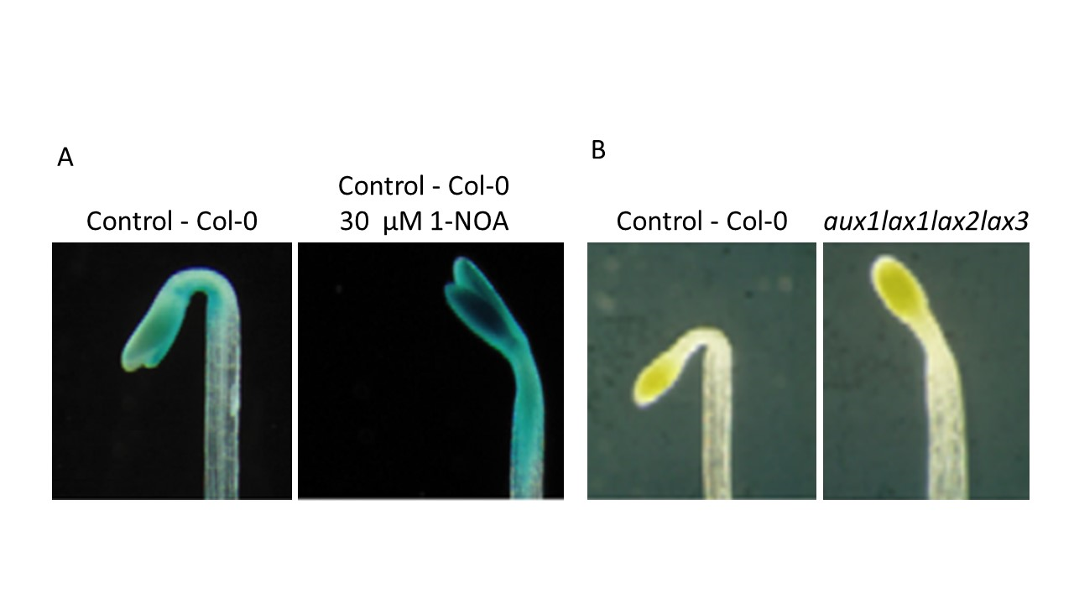

From this experiment, it is obvious that the inhibitor of auxin influx carrier 1-NOA disturbed the formation of apical hook and seedlings opened much faster **(A)** and that this effect is very similar to the situation in quadruple mutant *aux1lax1lax2lax3* lacking auxin influx carriers **(B)**.

The image on the left **(A)** also shows the distribution of auxin in these plants. The blue color indicates sites where the gene expression provoked by auxin takes place. Clearly, it is enhanced at the inner side of the hook, which is elongating less than the outer side. After the application of 1-NOA, this gradient cannot be formed. We ask the question on the importance of this process for the elongation of cells at both sides of the stem. For the purpose of the experiment on the left **(A)**, plants were transformed with the gene coding for ß-glucuronidase enzyme under the promoter sensitive to auxin. The expression of this enzyme takes place only when there is a sufficient amount of auxin around. Its activity subsequently creates a blue precipitate after the addition of chromogenic substrate to the fixed plants, X-gluc (5-bromo-4-chloro-3-indolyl ß – D glucuronide). The plants on the right **(B)** are either wild-type plants or plants carrying a quadruple mutation in all auxin influx carriers.

From these experiments, you can conclude on the importance of active auxin influx during the bending of the apical part of the hypocotyl A*rabidopsis thaliana* seedling.